

# Alcatel A3

## Type of device: Mobile

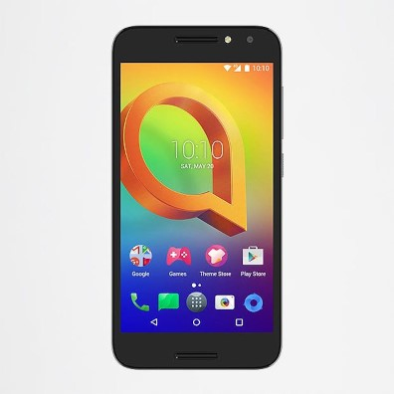

Actual Display Size : 5"

Button Type : Touchscreen

Operating System : Android

Version Number : 6

Network Capability : 3G,4G

Year of Release : 2017

Average Price : $116 as of 27 11 2019

## Accessibility Features:

### Cognitive

* Additional Instructions
* Copy and Paste
* GPS
* Photo Telephone List
* Screen Timeout Disabled
* Simple Reminders
* Simplify Display

Voice Notes

### Hearing Impairment and Deaf

* Allows for sign language communication
* Bluetooth or Wi-Fi
* Closed Captioning
* Front Facing Camera
* Hearing Aid Microphone Coupling
* Text Messaging/SMS
* Video Communications - Two-way

Visual Alerts - Incoming Calls

### Vision

* Battery Alert - Audible
* Bluetooth or Wi-Fi
* Braille Display Support
* Brightness Adjustable
* Dictation / Speech-to-Text
* High Contrast Mode
* Key Numbers - Standard Layout
* Key Press - Vibration or Click
* Power Cue
* Screen Magnifier
* Screen Reader
* Text Size Adjustable
* Text Style Adjustable
* Voice Control /Personal Assistant

Voiced Menus

### Speech

* Allows for sign language communication
* Bluetooth or Wi-Fi
* Messaging Options - Email
* Messaging Options - IM

Messaging Options - MMS

### Physical

* Automatic Answer
* Bluetooth or Wi-Fi
* Dictation / Speech-to-Text
* Flat Back for Table Top Operation
* Headset - plug connected
* Predictive Text
* Speaker-phone option
* Stylus or Prosthetic Device support
* Switch control option
* Voice Control / Personal Assistant
* Voice Recognition for Accessing Features

Voice Recognition for Dialling

## How and where to get it from?

You can buy this phone from [Optus](https://www.optus.com.au/shop/prepaidmobile/alcatel/a3), [MobileCiti](https://www.mobileciti.com.au/alcatel-a3-4g-lte-5-16gb-2gb-prime-black), [Harvey Norman](https://www.harveynorman.com.au/catalogsearch/result/?q=Alcatel+A3), and other retailers.

## More information is available on:

[Alcatel A3 User Manual (PDF Download)](http://pic1.aotcloud.com/tclportal/20170802/09/37/55/Mickey6_5046Y_5046D_UM_Eng_EN_04_170510.pdf)